**Institute of Engineering & Management**

**Department of Computer Science & Engineering**

**Network Lab for 3rd year 6th semester 2019**

**Code: CS 692**

**Date:** 01/04/19

**WEEK-6**

**Assignment-1**

**Problem Statement:** Standard Number Access Control List( denying access ).

**Screen-Shot:**

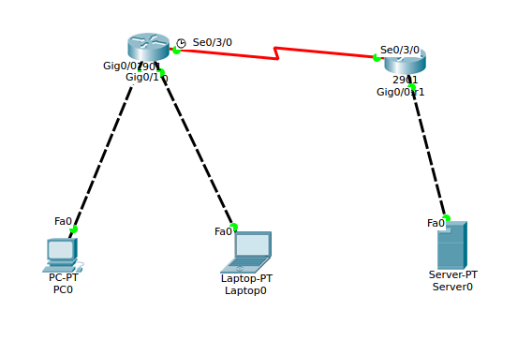

**Fig: Network**

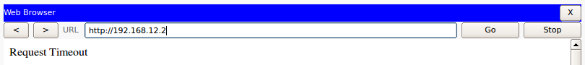

**Fig: Browser**

**CLI code:**

**Router-1:**

Router>en

Router#config terminal

Enter configuration commands, one per line. End with CNTL/Z.

Router(config)#interface gig0/0

Router(config-if)#ip address 192.168.10.1 255.255.255.0

Router(config-if)#no shutdown

Router(config-if)#

%LINK-5-CHANGED: Interface GigabitEthernet0/0, changed state to up

%LINEPROTO-5-UPDOWN: Line protocol on Interface GigabitEthernet0/0, changed state to up

Router(config-if)#exit

Router(config)#interface gig0/1

Router(config-if)#ip address 192.168.11.1 255.255.255.0

Router(config-if)#no shutdown

Router(config-if)#

%LINK-5-CHANGED: Interface GigabitEthernet0/1, changed state to up

%LINEPROTO-5-UPDOWN: Line protocol on Interface GigabitEthernet0/1, changed state to up

Router(config-if)#exit

Router(config)#interface se0/3/0

Router(config-if)#ip address 10.0.0.1 255.0.0.0

Router(config-if)#clock rate 64000

Router(config-if)#no shutdown

%LINK-5-CHANGED: Interface Serial0/3/0, changed state to down

Router(config-if)#exit

Router(config)#router rip

Router(config-router)#network 192.168.10.0

Router(config-router)#network 192.168.11.0

Router(config-router)#network 10.0.0.0

Router(config-router)#version 2

Router(config-router)#exit

Router(config)#

**Router-2:**

Router>en

Router#config terminal

Enter configuration commands, one per line. End with CNTL/Z.

Router(config)#interface gig0/0

Router(config-if)#ip address 192.168.10.1 255.255.255.0

Router(config-if)#no shutdown

Router(config-if)#

%LINK-5-CHANGED: Interface GigabitEthernet0/0, changed state to up

%LINEPROTO-5-UPDOWN: Line protocol on Interface GigabitEthernet0/0, changed state to up

Router(config-if)#exit

Router(config)#interface gig0/1

Router(config-if)#ip address 192.168.11.1 255.255.255.0

Router(config-if)#no shutdown

Router(config-if)#

%LINK-5-CHANGED: Interface GigabitEthernet0/1, changed state to up

%LINEPROTO-5-UPDOWN: Line protocol on Interface GigabitEthernet0/1, changed state to up

Router(config-if)#exit

Router(config)#interface se0/3/0

Router(config-if)#ip address 10.0.0.1 255.0.0.0

Router(config-if)#clock rate 64000

Router(config-if)#no shutdown

%LINK-5-CHANGED: Interface Serial0/3/0, changed state to down

Router(config-if)#exit

Router(config)#router rip

Router(config-router)#network 192.168.10.0

Router(config-router)#network 192.168.11.0

Router(config-router)#network 10.0.0.0

Router(config-router)#version 2

Router(config-router)#exit

Router(config)#

Router#config terminal

Enter configuration commands, one per line. End with CNTL/Z.

Router(config)#access-list 112 deny tcp 192.168.10.0 0.0.0.255 192.168.12.2 0.0.0.0 eq 80

Router(config)#access-list 112 permit ip any any

Router(config)#interface gig0/0

Router(config-if)#ip access-group 112 out

Router(config-if)#exit

Router(config)#